Template for FOP 2026 (Arial 14 Point Bold)
^{1,#}First Author,²Second Author and ³Third Author (Arial 12 point)
¹Afflitiation with full address (Arial 11 point)
²Afflitiation with full address
³Afflitiation with full address
#email id of the corresponding author (Arial 10 point italics)
A short abstract in italicized font (Arial 10 point) showing the main highlights and important findings of the research work to be presented. Please limit the abstract to about 50 words (maximum 4 lines). Leave one line gap after the abstract.

The main summary of the research work could be divided into different paragraphs with figures and equations. The text should begin with a paragraph of introduction giving clearly the context of the work. Text of the summary should be in Arial 10 point. No sections headings should be used. The page size of A4 should be used with ‘Normal’ margins (1 inch on all four sides). The maximum page limits is 2 pages. Use 8 point spacing after paragraphs. No indent in the first line of the paragraph.
Lorem Ipsum is simply dummy text of the printing and typesetting industry. Lorem Ipsum has been the industry's standard dummy text ever since the 1500s, when an unknown printer took a galley of type and scrambled it to make a type specimen book. It has survived not only five centuries, but also the leap into electronic typesetting, remaining essentially unchanged. It was popularised in the 1960s with the release of Letraset sheets containing Lorem Ipsum passages, and more recently with desktop publishing software like Aldus PageMaker including versions of Lorem Ipsum.
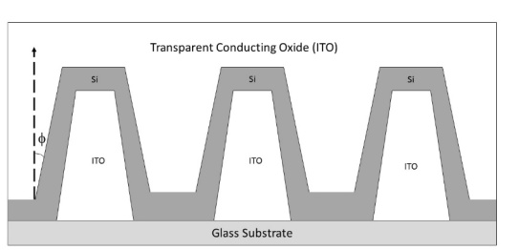
Fig. 1: Figure caption

The figure along with its caption be inserted in a text box which is interspersed with the paragraph using the ‘tight’ wrapping option in Layout options. The figure caption should be in size 8 and italicized.
Inserts like tables, smart-art, charts etc should be inserted into a text box along with their captions.
Equations should be centered and could be numbered if they are referred to later in the text.
$ax^{2}+bx+c=0$ (1)
The sample reference template is provided in the references section. Please observe that we follow a concise presentation for citing references where the paper title is omitted. A similar approach should be followed for citing conference presentations. The font for citing references should be 8 points Arial. The name of the journal should in italics. A citation must contain the list of authors, title of the Journal/ Conference/ Book, issue, volume, page number and year. A sample book citation is [1], a journal could be cited as [2], while a conference paper as [3]. This style is a slightly modified version of the style referred to as ‘Elsevier (numeric, without titles)’.
The abstract could end with a concluding paragraph and a statement on acknowledgements.
References:
[1] A.K. Ghatak, K. Thyagarajan, Optical Electronics, Cambridge University Press, Cambridge (1989).
[2] L.C. Venuti, T. Albash, D.A. Lidar, P. Zanardi, Physical Review A 93 (2016) 032118.
[3] S. Sunder, A. Sharma, Workshop on Recent Advances in Photonics, (WRAP 2019) 19 (2019).
File Naming Format:
Please name your file as: [ConferenceAreaShortform (as listed on the website home page)_LastName_FirstName_FOP_2026.pdf]
For example: QOT_Bob_Alice_FOP_2026.pdf, where QOT refers to Quantum Optical Technologies.

